JOHNNY & RENA NUNLEY
MISSIONARIES TO BRAZIL
_______________________________________________________________________April 2013________________
Dear Friends,
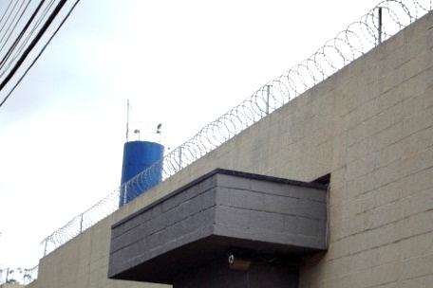
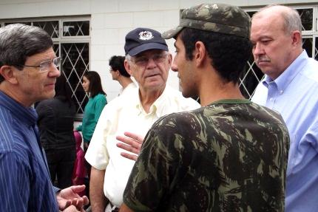
On a Saturday afternoon in January I gave a message at a men’s picnic about Simon, the Cyrenian, who was unexpectedly placed in a cross-bearing mission for the Lord Jesus. I think the message was intended mostly for me because a short while later I was unexpectedly asked to serve for three days as an interpreter for two American evangelists who work in international prison ministries. A Brazilian pastor and I ended up investing a week in which we visited five prisons with the evangelists and presented the gospel to hundreds of incarcerated men and women. Many “decisions” for Christ were made and hopefully there were genuine conversions among these. Whatever were the true results, a great opportunity had been given for preaching the gospel.
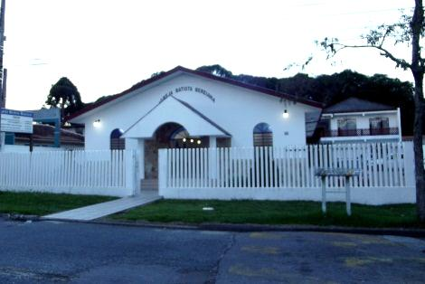
After finishing up our brief pulpit-supply ministry at Victory Baptist Church in February we received an invitation to help Berea Baptist Church which had been without a pastor for about three months. This church has a thirty-year history and was started by Missionaries Neal & Alice Smith. It has had both American and Brazilian pastors through the years and in recent months the church has suffered deep wounds and has lost about half of its 70+ members. Our goal is to see the church restored and under Brazilian leadership again. We have taken steps to reorganize the church and have been encouraged to see some members returning, attendance increasing and several gladly offering themselves to serve.
It was also encouraging when a young man in the church named André told me that he had received Christ after a message I preached at a youth camp a couple years ago. I was not aware that this had taken place and I now look forward to preparing André and four others for baptism in a few weeks.
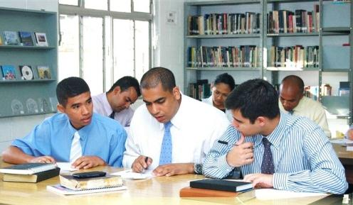
In March, classes resumed with 39 students at the Bible Institute. Rena is teaching English and piano and also records the students’ weekly Christian service reports as well as managing a busy snack shop. I am teaching Analysis of Daniel & The Revelation, Homiletics, Missions and also a non-credited piano tuning course.
We are optimistic about the challenges that God has placed before us and we are very thankful for your gifts and prayers which have enabled us to meet these challenges.

Sincerely in Christ, Johnny & Rena Nunley
E-mail: jnunleyfamily@juno.com Website: nunleysbrazil.weebly.com
Brazil Snail Mail: Caixa Postal 502, Pinhais, PR Brazil, 83323-990
Home Church: First Baptist Church of Draper, P.O. Box 4428, Eden, NC 27289

