JOHNNY & RENA NUNLEY
Missionaries to Brazil
___________________________________________________________________________________June 2014
Dear Friends,
The World Cup of soccer produces a national phenomenon in Brazil like nothing we have ever seen in the States. The day the Brazil team plays, busy streets become practically abandoned. Businesses and factories close down all over the country as people get together before big screens in public squares or before TV’s in bars, restaurants or in their own homes. When a goal is made the whole country explodes in fireworks and various forms of jubilant festivities.
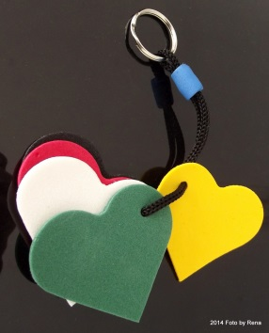
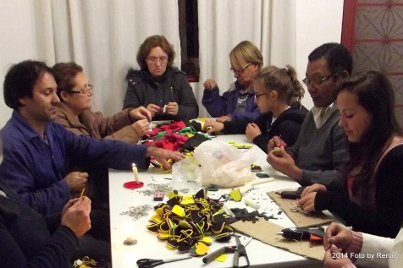
Since Brazil is the host country this year thousands of people from around the world have converged here to watch the games. This has provided a unique opportunity for evangelistic outreach. Colleagues with BMM produced a special tract of which thousands have been distributed. Besides participating in the distribution of this tract, our church helped us produce 3,000 Wordless Book key chains for presentation during the games, too. Please pray with us for God’s blessings upon the seeds that have been sown.
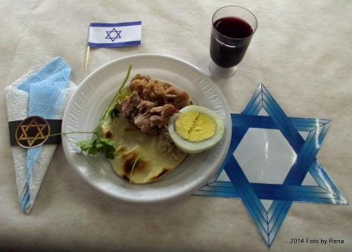
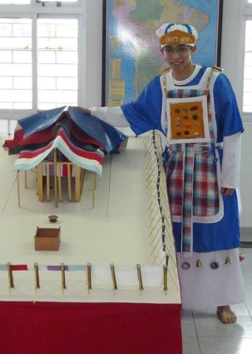
In addition to our normal church ministry, other activities have been focused primarily in the classroom of the Parana Bible Institute. Teaching Analysis of Exodus/Leviticus this semester has been rewarding. The students revealed their creativity in presenting a modern version of the Passover meal and also a beautiful reproduction of the high priest’s clothing. We also had a “ field trip” (across the street) to observe the measurements some of the students had staked out for the Tabernacle, plus the representative groupings of the tribes around the Tabernacle with their banners.
We concluded our study of the book of Leviticus with an overview of God’s seven appointed feasts for Israel. In the prophetic view of the Feasts, the fourth one was fulfilled with the inauguration of the church on the day of Pentecost. We await the fifth one to be fulfilled with the Feast of Trumpets. Would this have anything to do with the Rapture? Just a glance around our troubled world should make us long for a new earth in which peace and righteousness dwell. King Jesus needs to return soon. We want to “occupy” until that Day comes.
Sincerely in Christ,
Johnny & Rena Nunley
E-mail: jnunleyfamily@juno.com Website: nunleysbrazil.weebly.com
Snailmail: Caixa Postal 502 Pinhais, PR Brazil, 83323-990
Home Church: First Baptist Church of Draper, P.O. Box 4428, Eden, NC 27289

